**EXPERIMENT 1**

|  |  |
| --- | --- |
| **Name:** | Keerti P. Charantimath |
| **Roll Number:** | 19MA20059 |

**Familiarisation with Resistor**

1. **Aim of the experiment:**

* To understand the functioning of resistors.
* To measure the resistance and tolerance of a resistor.

1. **Tools used:**

* Resistors of different types, with different resistances and tolerance.

1. **Background knowledge:**

* There are two types of resistors viz. fixed and variable resistors.
* A fixed resistor is the one whose value cannot be changed (Eg.: Carbon film, wire film and wire wound resistors.)
* A variable resistor is the one whose resistance can be changed. (Eg.: Semi fixed resistor, completely   
  variable resistor, potentiometer)
* Reading the value of fixed resistors: Resistors are color coded with 4 or 5 bands of color. This is done as they are too small to have actual value written on them. Decoding these colors can give the value of resistance and tolerance of the resistor.

1. **Reference Table:**

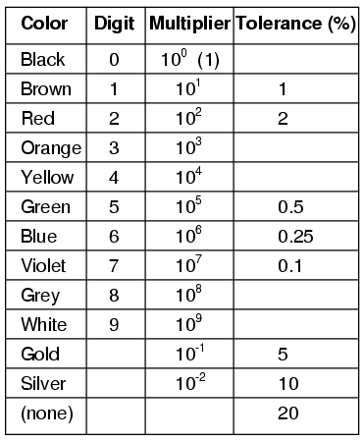

Table with band colors and their respective number, multiplier, and tolerance values.

1. **Image/Screenshot:** 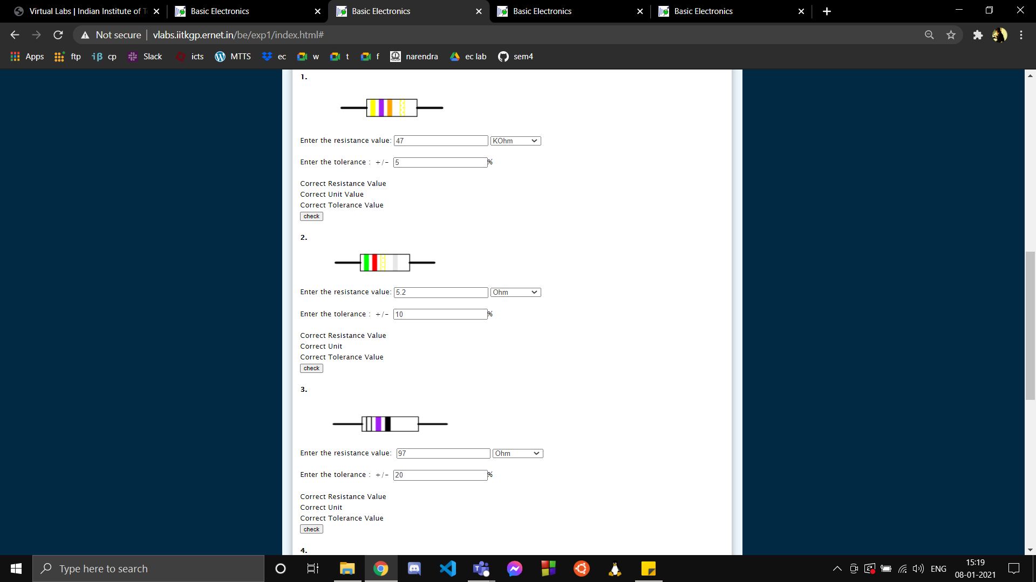 

Screenshots of Quiz given on recognizing resistance and tolerance values of resistors   
( vlabs.iitkgp.ernet.in )

1. **Conclusion:**

* Resistance is a measure of the opposition to current flow in an electrical circuit. It is measured in ohms.
* A resistor is a passive two-terminal electrical component that implements electrical resistance in a circuit.
* The tolerance of a resistor is the maximum difference between its actual value and the required value and is generally expressed as a plus or minus percentage value.
* A resistor might have 4 or 5 color coded bands.
* For a 4 banded resistor, first 2 bands give the number, 3rd band gives the multiplier value and the last band represents the tolerance value.
* For a 5 banded resistor, first 3 bands give the number, 4th band gives the multiplier and the last band represents the tolerance value.
* To find the resistance and tolerance, we need to recognize which band represents what, and then recognize the color and decode its value according to the reference table (shown on page 1).

1. **Discussions:**

* We need to place the resistor in such a way that the closely packed color bands are on the left else we might end up reading the wrong value.
* We also need to check if a resistor is 4 banded or 5 banded before reading its value. If 3 bands are closer to each other and 1 band is far apart or is missing then the resistor is a 4 banded resistor. If 4 bands are closer and 1 other band is either far apart or missing then it is a 5 banded resistor.

**Familiarisation with Capacitor**

1. **Aim of the experiment:**

* Define capacitor and identify the value of its capacitance.
* Understand their construction and functioning.
* Find energy associated with a capacitor.

1. **Tools used:**

* Capacitors with different values of capacitance.

1. **Background knowledge:**

* A capacitor is a device that stores electrical energy in an electric field. It is a passive electronic component with two terminals. The effect of a capacitor is known as capacitance measured in Farads.
* The higher the value of capacitance, the more charge the capacitor can store.
* A basic capacitor consists of two metal plates separated by a dielectric (insulating materials like air, glass etc).

1. **Image/Circuit:**

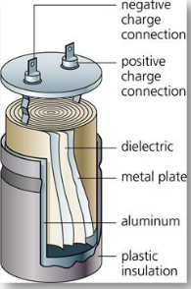

Construction of a capacitor

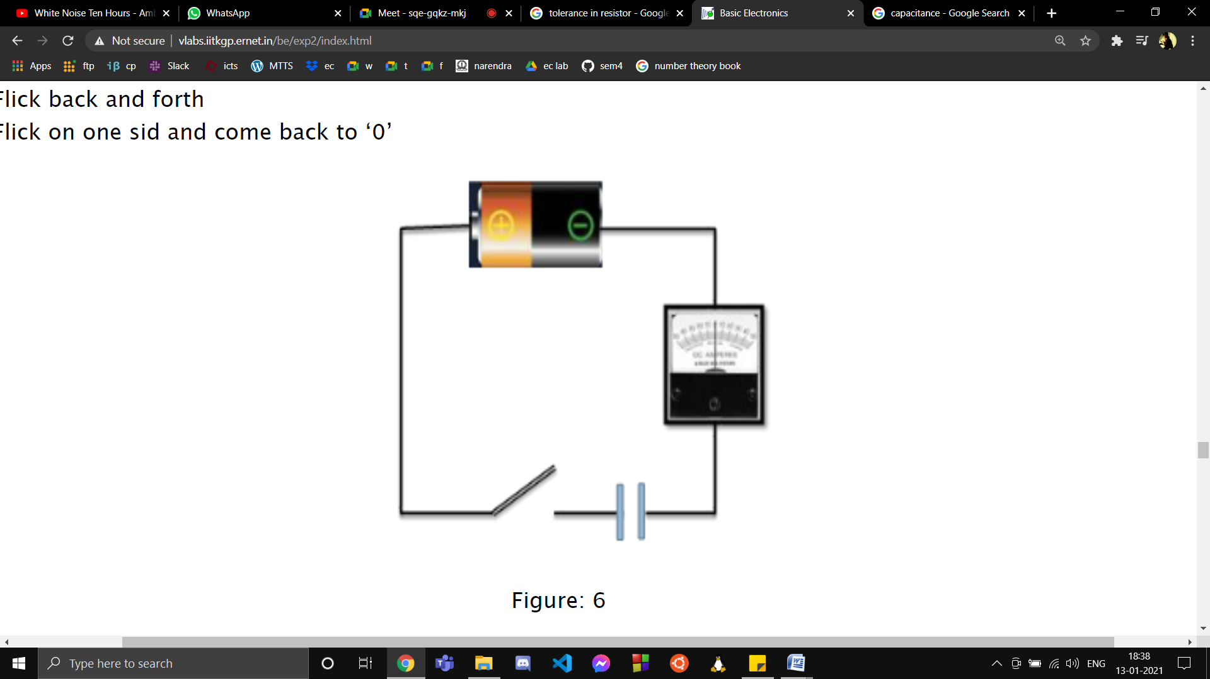

A basic circuit connecting a dc voltage source(battery), a galvanometer, a capacitor and a switch.

1. **Screenshots:**

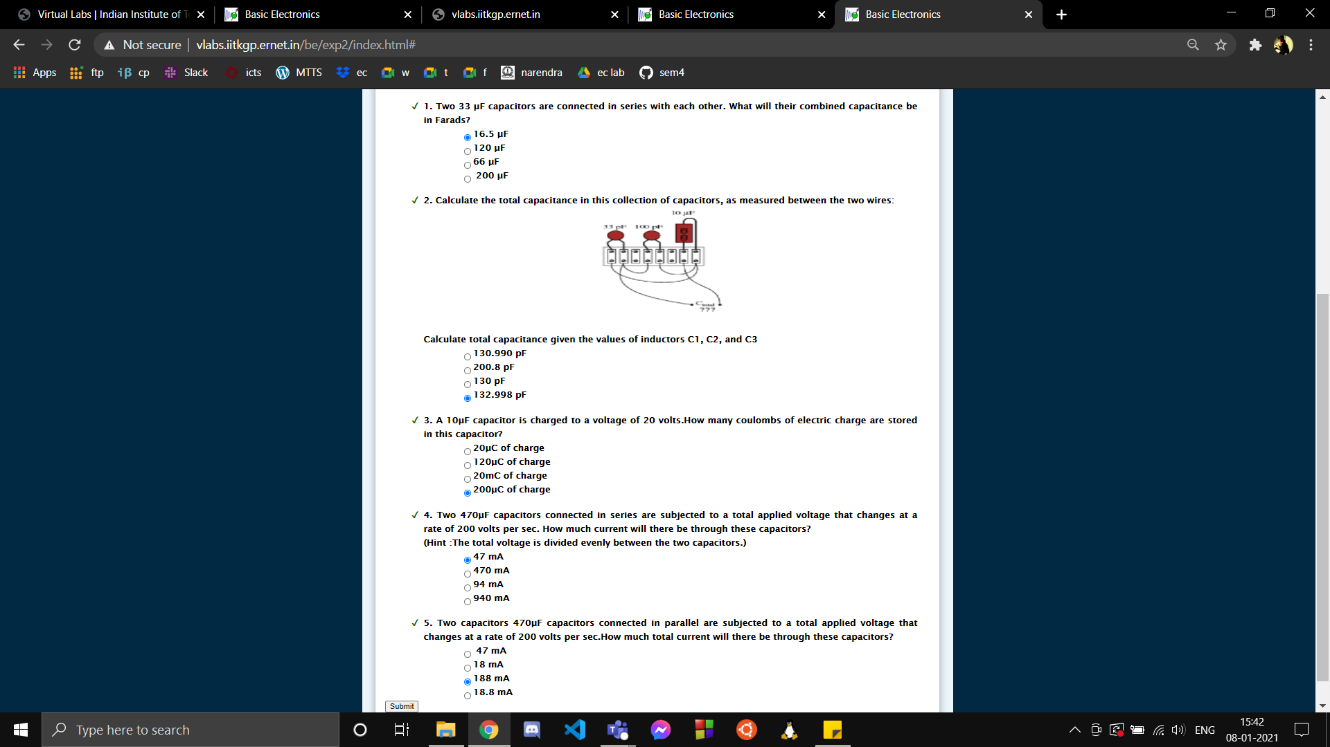

Screenshots of Quiz given on recognizing capacitance of various combinations of capacitors,   
current flowing through them and charge stored in them. ( vlabs.iitkgp.ernet.in )

1. **Conclusion:**

* The capacitance C is the ratio of the amount of charge q on either conductor to the potential difference V between the conductors. [ C = q/V ]  
  Here:   
  C -> Capacitance  
  q -> Charge  
  V -> Potential Difference
* Differentiating the above equation with respect to time, we get the equation for current flow through the capacitor in the presence of variable potential difference. [ I= C(dv/dt) ]  
  Here:   
  C -> Capacitance  
  t -> Time  
  v -> Potential Difference  
  I -> Current
* The equivalent capacitance (C) of n capacitors (C1,C2,C3,...,Cn) connected in parallel is given by:  
  C=C1+C2+C3+…+Cn

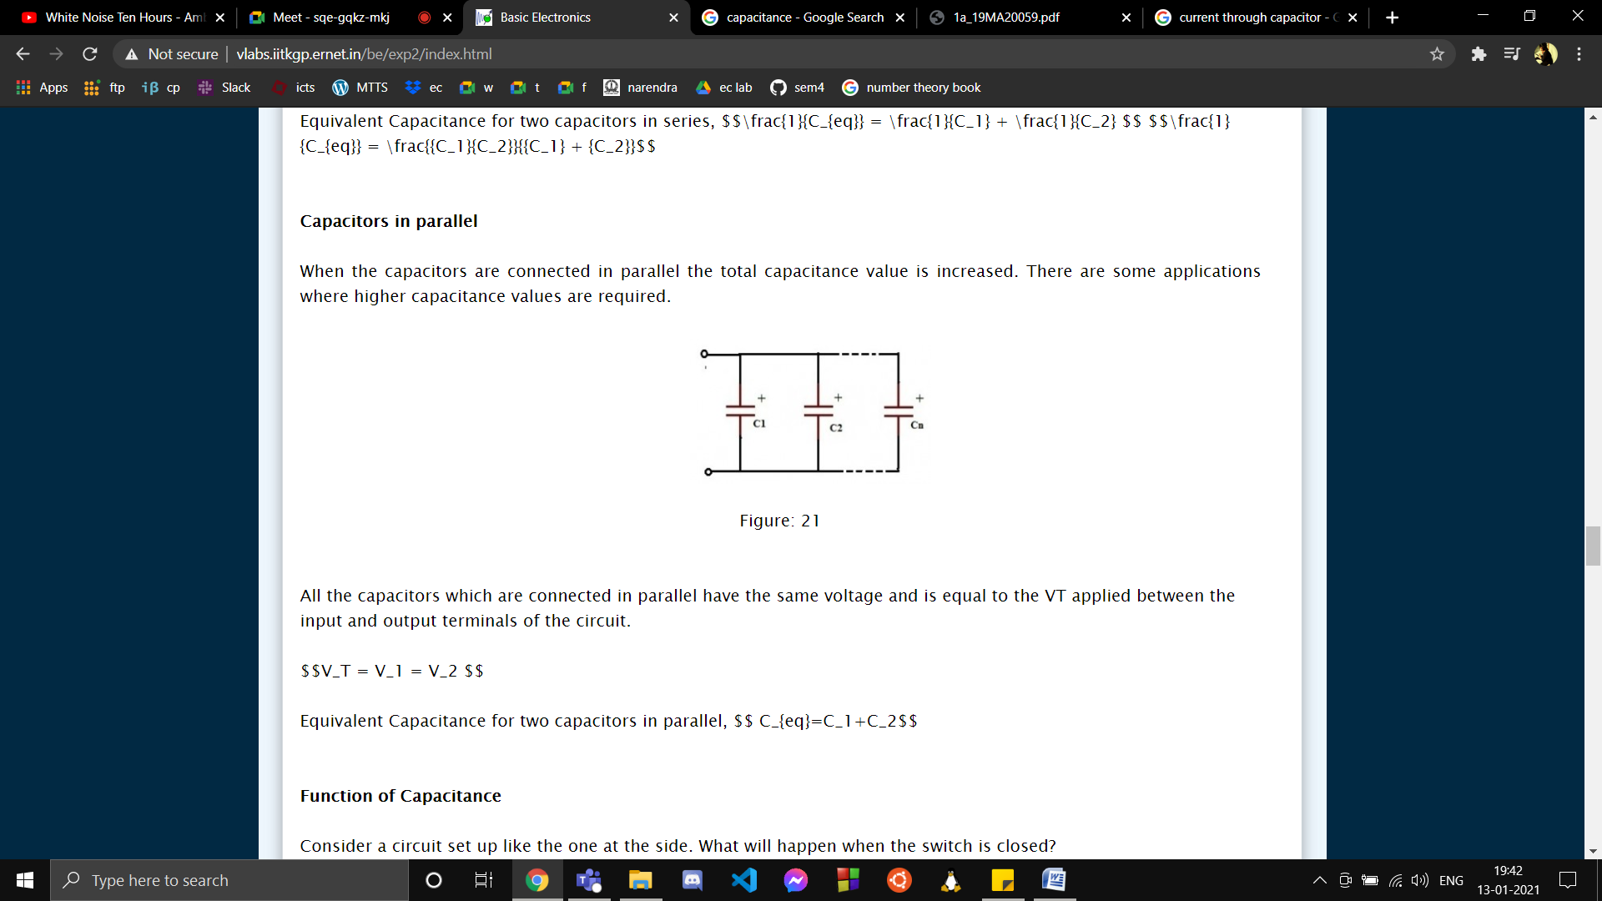

* The equivalent capacitance (C) of n capacitors (C1,C2,C3,...,Cn) connected in series is given by:  
  C-1=C1-1+C2-1+C3-1+…+Cn-1

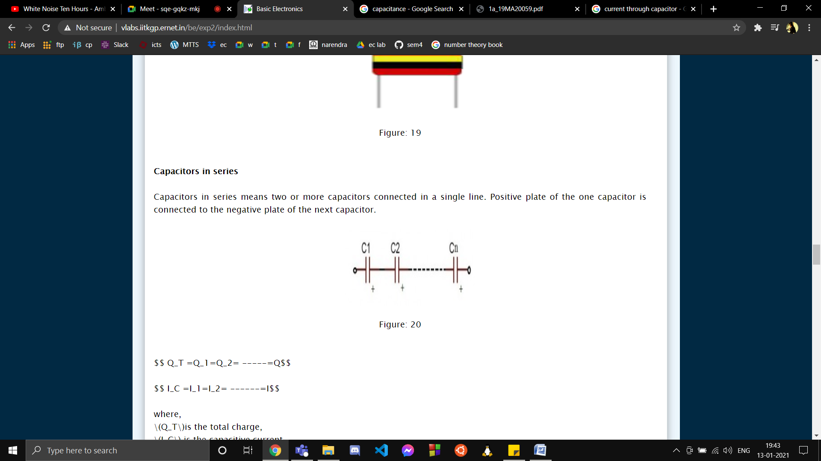

1. **Discussions:**

* Every capacitor has a maximum working voltage beyond which, the insulator between the plates fails and charge passes from one plate to the other. To avoid this situation we need to ensure (especially for AC circuits) that the voltage across the capacitor is always less than about two thirds of this value.
* Capacitor is a basic storage device to store electrical charges during a process called charging and release it as it is required by the circuit in a process called discharging.
* Charging:  
   1 . A battery is connected to an uncharged capacitor.  
   2 . Due to the applied potential difference, electrons start moving from the plate connected to negative  
   terminal.  
  3 . This creates a potential difference between the plates.  
  4 . This process continues till the potential difference between the plates becomes equal to the potential   
   difference offered by the battery.   
  5 . Once this point is reached, the capacitor is said to be charged and has the same voltage as the battery.
* Discharging:  
  1 . The charged capacitor now behaves like a battery.   
  2 . Until it is discharged completely, it keeps acting like a battery.  
  3 . The potential difference it offers is not constant and keep decaying until the point of complete discharge.

**Familiarisation with Inductor**

1. **Aim of the experiment:**

* Understanding the basic functioning of inductors
* Evaluating the inductance

1. **Tools used:**

* Inductors of different values of inductance.

1. **Background knowledge:**

* An inductor is a passive electrical component that stores energy in a magnetic field when electric current flows through it. The effect of inductor is known as inductance measured in Henry.
* Inductance is the tendency of an electrical conductor to oppose a change in the electric current flowing through it.
* An inductor is constructed by winding a wire around a hollow or solid core.

1. **Image:**

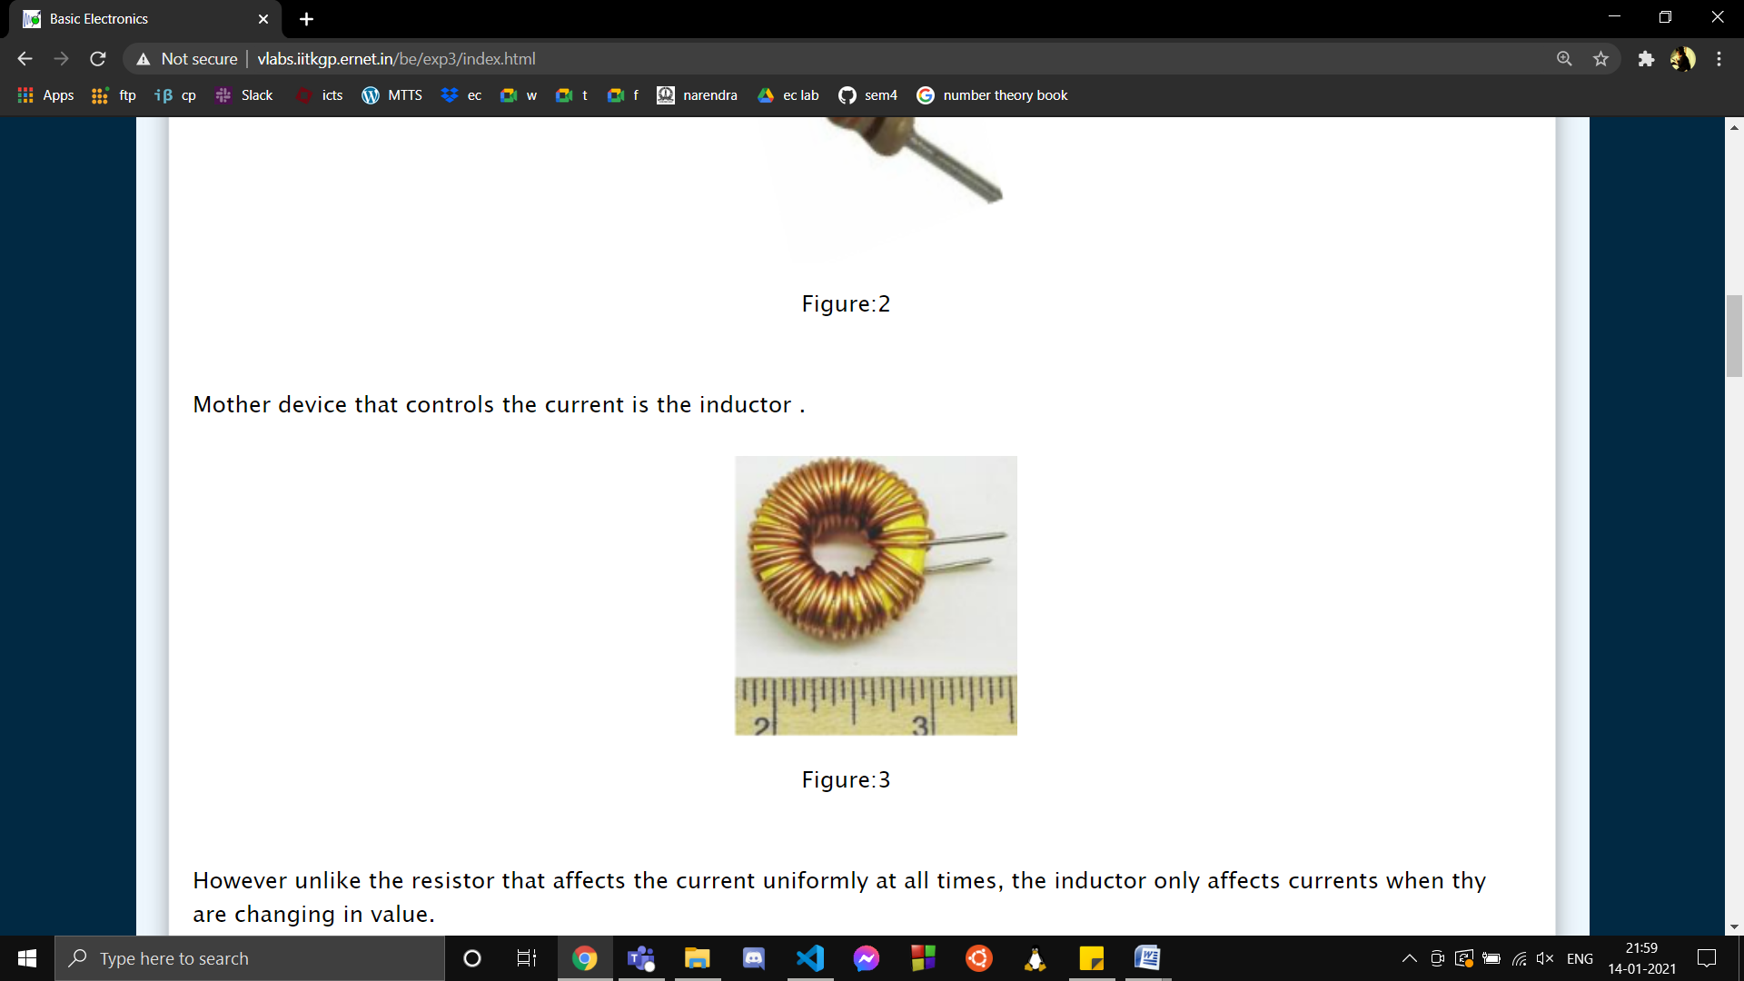

Construction of a simple inductor

1. **Screenshots:**

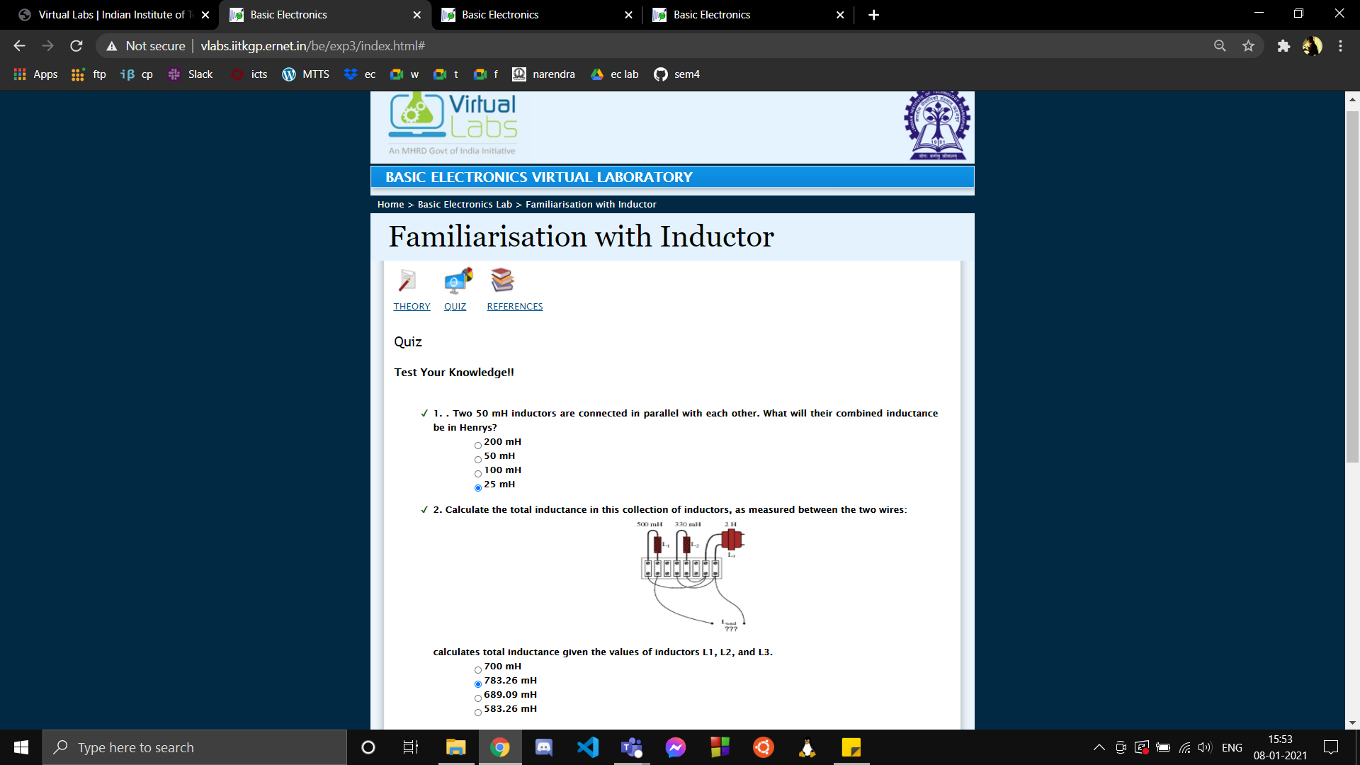

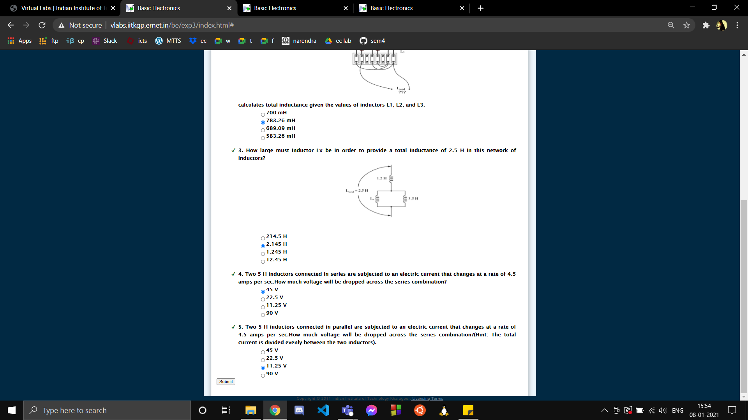

Screenshots of Quiz given on recognizing inductance of various combinations of inductors and   
voltage drop across them. ( vlabs.iitkgp.ernet.in )

1. **Conclusion:**

* The equation showing current-voltage relationship in an inductor is given by: V=L(dI/dt)  
  Here:  
  V -> Voltage drop across the Inductor  
  L -> Inductance of the inductor  
  I -> Current  
  t -> Time
* Inductance of an inductor is given by the following expression: L= (nr no A N2 )/l  
  Here:  
  L -> Inductance  
  nr -> Relative permeability of core  
  no -> Permeability of the free space  
  A -> Cross-section area of the core  
  N -> Number of turns of the wire  
  l -> Length of the coil
* The equivalent inductance (L) of n inductors (L1,L2,L3,...,Ln) connected in series is given by:  
  L=L1+L2+L3+…+Ln
* The equivalent inductance (L) of n inductors (L1,L2,L3,...,Ln) connected in parallel is given by:  
  L-1=L1-1+L2-1+L3-1+…+Ln-1

1. **Discussions:**

* Inductance is the property of the inductor through which it opposes change in electric current through it.

Inductance of an inductor is dependent on various factors as follows:  
1 . Increases with increase in number of turns.  
2 . Increases with increase in cross sectional area of the core.  
3 . Decreases with increases in length of the solenoid/coil.  
4 . Increases with increase in permeability of core.  
By changing these parameters we can vary the inductance according to our convenience.